Sustainable Computing Project Candidate number: 1085060
- Methodology
Datasets
Grid intensity data was sourced from Historic generation mix and carbon intensity [1] and real time carbon intensity is retrieved from Carbon Intensity API [2].
SARIMA models
The SARIMA model is selected as the non-ML method, as seasonality is expected in units of months or weeks or days, in the visualisation process it is observed that there is negative drift in the data across the last years, which using the differentiation function it can be captured. It is expected that it is quite suitable for higher time frame (monthly) predictions but will become quite computationally intensive for hourly predictions, as we are looking at longer cycles, for example weeks with time steps of 168, the maximum likelihood fitting function in SARIMA will be exponentially complex with the size of this seasonal period. We use auto_arima from pmdarima library [3] fitting on all monthly datapoints in the dataset. For the hourly forecast, length of the dataset which the optimizer operated on had to be reduced to the last 720 datapoints.
Monthly and hourly multilayer perceptron (MLP)
The MLP neural network has been selected for forecasting as it is able to take multiple inputs such as lags, time features and moving averages at the same time, we are able to supervise the model to strictly take the lags of certain time cycles (days or weeks or months) for an efficient learning process, as grid cycles tend to be strictly cyclic. It is expected to be scalable and suitable in all cases but will require a more complex network to learn hourly patterns. The MLP is implemented using MLPRegressor from Sklearn library [4].
Table 1 Monthly MLP architecture
Input Layer | $CI(t-1), CI(t-2), CI(t-3), CI(t-6), CI(t-12), MA(3), MA(6), MA(12)$, month, year.
Hidden Layers | 64 relu activated neurons; 32 relu activated neurons
Optimizer | Adam, minimising the MSE for validation dataset.
Data Splitting | Train: 2009 to 2023; Validation: 2023 to 2024; Test: 2024 to 2025

Table 2 Hourly MLP architecture
Input Layer | hour, day of the week, month, day of year, year, $CI(t-1), CI(t-24), CI(t-168), MA(24), MA(168)$
Hidden Layers | Layer 1: 100 neurons, Layer 2: 50 neurons.
Optimizer | Adam, minimising the MSE for validation dataset.
Data splitting | Train: 2009 to 2023; Validation: 2023 to 2024; Test: 2024 to 2025

Multithreading
In the SARIMA model, the auto_arima parameter fitting method can be ran using multi-threads, so it is ran using 4 CPU threads, setting stepwise to False for parallel processing. For MLP, Multithreading can be applied at the feature engineering step; the model training step uses the SciPy and NumPy libraries that already implement multi-threading optimally.
Operating on smaller datasets:
For the hourly SARIMA model, the subset has been reduced to 480 data points. For other models, it has been decided that data for time period 2009 to the end of 2015 to be irrelevant.
Improving bottlenecks:
There are two major run time intensive sections, reading the csv file and fitting the models. The csv file can be directly compiled to parquet. The resample method to month can be conducted on the hourly dataset. The fitting for SARIMA can be accelerated by using Fourier variables; MLP model can be accelerated by increasing the batch size.
- Results and Discussion

Base models
Table 3 Base model forecasts
 | MAE | RMSE | Run time (s) | Energy used (J) | Carbon emission (gCO2)
Monthly SARIMA | 18.09 | 20.36 | 14.56 | 410.59 | 0.031
Monthly MLP | 14.32 | 18.39 | 1.42 | 21.87 | 0.0017
Hourly SARIMA | 58.16 | 74.26 | 103.64 | 3178.39 | 0.24
Hourly MLP | 6.39 | 8.45 | 64.28 | 1376.18 | 0.10

Multithreading
Table 4 Forecast using multi-threading
 | MAE | RMSE | Run time (s) | Energy used (J) | Carbon emission (gCO2)
Monthly SARIMA | 18.09 | 20.36 | 15.8060 | 578.4 | 0.044
Monthly MLP | 15.21 | 19.5 | 1.8597 | 91.79 | 0.0070
Hourly SARIMA | 64.43 | 83.05 | 26.32 | 902.81 | 0.069
Hourly MLP | 6.39 | 8.45 | 59.8507 | 1626.06 | 0.12

There is only significant runtime reduction in the hourly SARIMA forecast, producing similar errors to the base version. The MLP models have very slight improvements thanks to faster data pipelining.
Smaller datasets
Table 5 Forecast using data points 2015 onwards
 | MAE | RMSE | Run time (s) | Energy used (J) | Carbon emission (gCO2)
Monthly SARIMA | 24.13 | 27.22 | 10.2212 | 33.81 | 0.0026
Monthly MLP | 9.23 | 11.58 | 1.3364 | 33.47 | 0.0025
Hourly SARIMA | 182.27 | 215.06 | 117.74 | 2690.86 | 0.20
Hourly MLP | 6.38 | 8.42 | 55.9615 | 1265.97 | 0.096

Thanks to the selection of data points to remove the MLP models are fitted with much better accuracy, with also improvements in run time. The SARIMA models run times improve but errors remain large.
Bottleneck improvements
The parquet conversion and filtering take 0.7824 seconds, which takes 6.81 J of energy, producing 0.00052 grams of CO2, which is negligible.
Table 6 Fully optimized carbon emissions
 | MAE | RMSE | Run time (s) | Energy used (J) | Carbon emission (gCO2)
Hourly SARIMA | 66.99 | 84.43 | 31.72 | 1091.01 | 0.083
Monthly SARIMA | 25.96 | 28.97 | 14.86 | 1091.01 | 0.083
Hourly MLP | 6.48 | 8.55 | 49.39 | 1098.86 | 0.084
Monthly MLP | 9.23 | 11.58 | 1.37 | 1098.86 | 0.084

After full optimization, all forecasting run time and energy costs are significantly reduced. The hourly SARIMA forecast still yields an unsatisfying result while the monthly yields similar results to base. The MLP models yield the same/similar forecast as the previous section.
Running optimized MLP forecasting in two different environments
Table 7 different coding environments
 | Energy used (J) | Carbon emission (gCO2)
Jupyter notebook | 1098.86 | 0.084
Python | 1060.90 | 0.081
The two environments use similar amount of energy and hence emit similar amounts of CO2.
Running optimized MLP forecasting in various locations and hours
Table 8 different location, time carbon emission table
 | CI (gCO2/kWh) | Energy used (J) | Carbon emission (gCO2)
OX1 26/12/2025 19:00 | 274 | 1098.86 | 0.084
SE1 26/12/2025 19:00 | 124 | 1098.86 | 0.038
B1 26/12/2025 19:00 | 212 | 1098.86 | 0.065
OX1 26/12/2025 9:00 | 156 | 1098.86 | 0.048
OX1 26/12/2025 19:00 | 274 | 1098.86 | 0.084
OX1 26/12/2025 21:00 | 261 | 1098.86 | 0.080

- Conclusions
Using the previously mentioned optimization techniques, forecasting models can be significantly made faster and more accurate, hence emitting less CO2. However, the time and location of the device running the project also play a significant role in the carbon emission, as observed in Table 6, at some times during the day and in some locations, even the optimized code emits the same amount of CO2 as unoptimized code.
- Computer Hardware and Programs
Processor | Processor 12th Gen Intel(R) Core(TM) i5-1235U (1.30 GHz)
RAM | Installed RAM 16.0 GB (15.7 GB usable)
System | System type Windows 11, 64-bit operating system, x64-based processor
IDE | IDE: visual studio code

- References and acknowledgements
[1] NESO. (2023). Historic generation mix and carbon intensity. Retrieved December 16th 2025, from https://www.neso.energy/data-portal/historic-generation-mix
[2] NESO. (2023). Carbon Intensity API. from https://carbonintensity.org.uk/
[3] T. G. Smith et al., "pmdarima: ARIMA estimators for Python," version 2.0.4, 2017.from http://alkaline-ml.com/pmdarima
[4] F. Pedregosa et al., "Scikit-learn: Machine learning in Python," J. Mach. Learn. Res., vol. 12, pp. 2825–2830, 2011.

Appendix
Code GitHub URL: https://github.com/CalvoSeko/sustainable-computing-coursework-tianwei
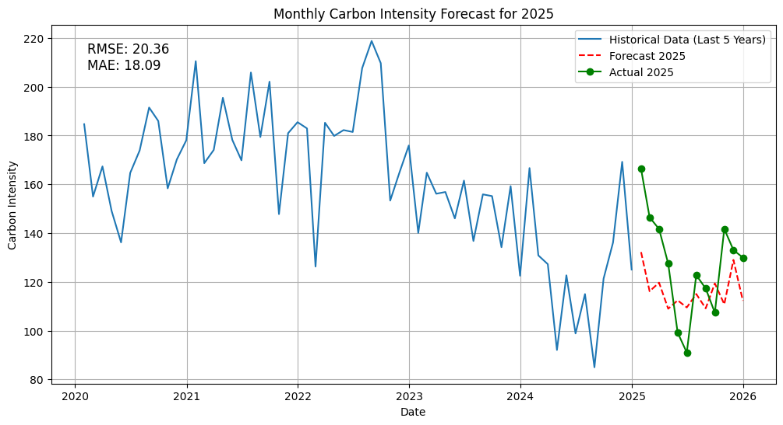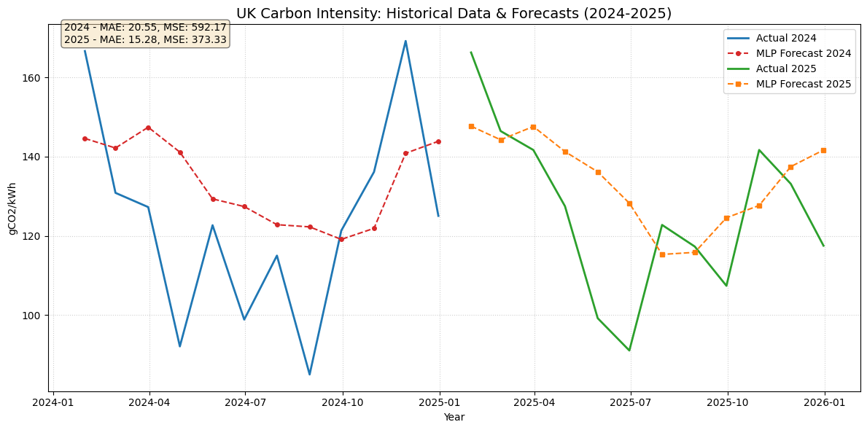
Figure 1 a) Monthly SARIMA model forecast (no optimization) b) Monthly MLP model forecast (no optimization)
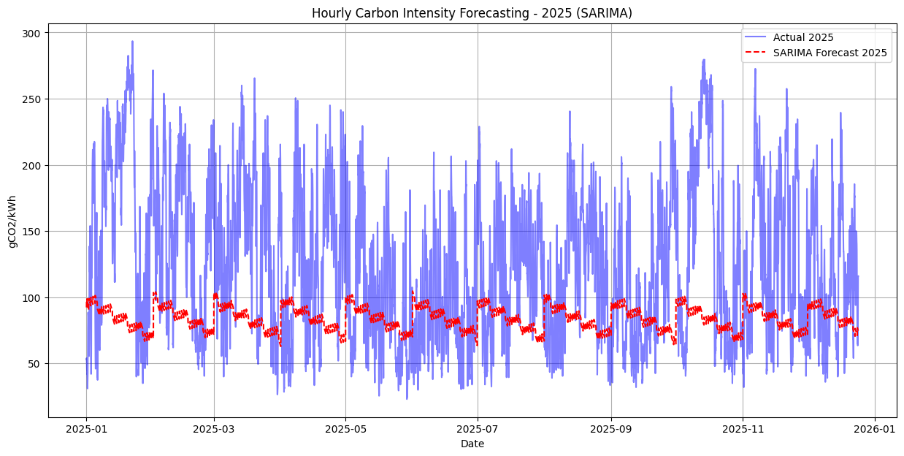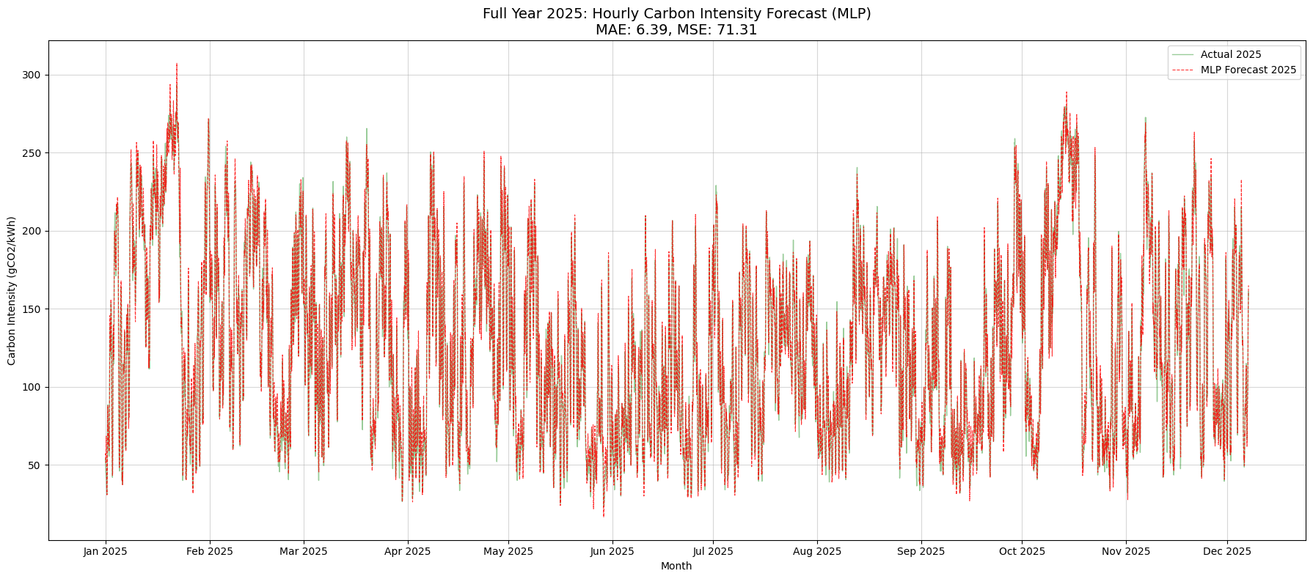
Figure 3 Hourly SARIMA and MLP forecast without optimization
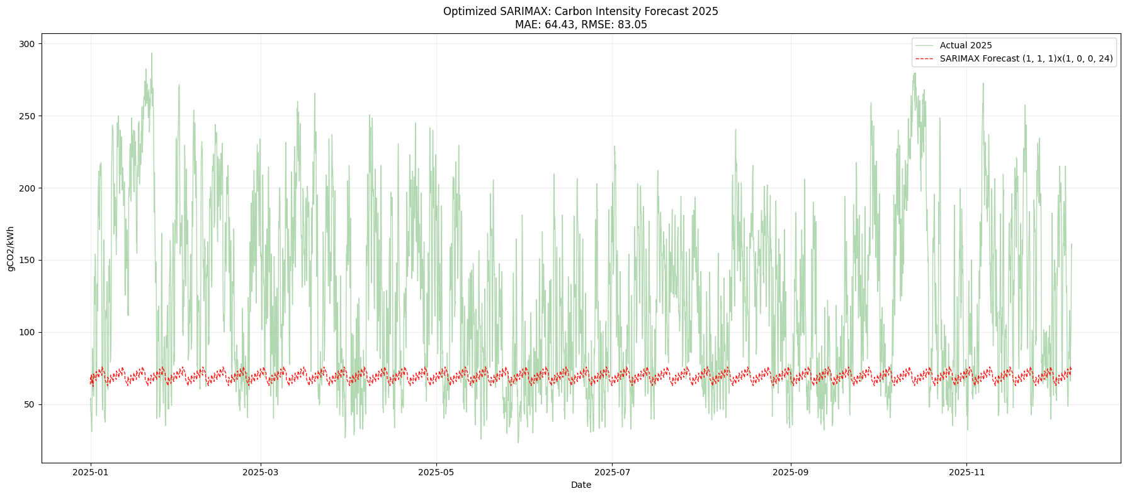
Figure 5 SARIMA hourly forecast using multithreading
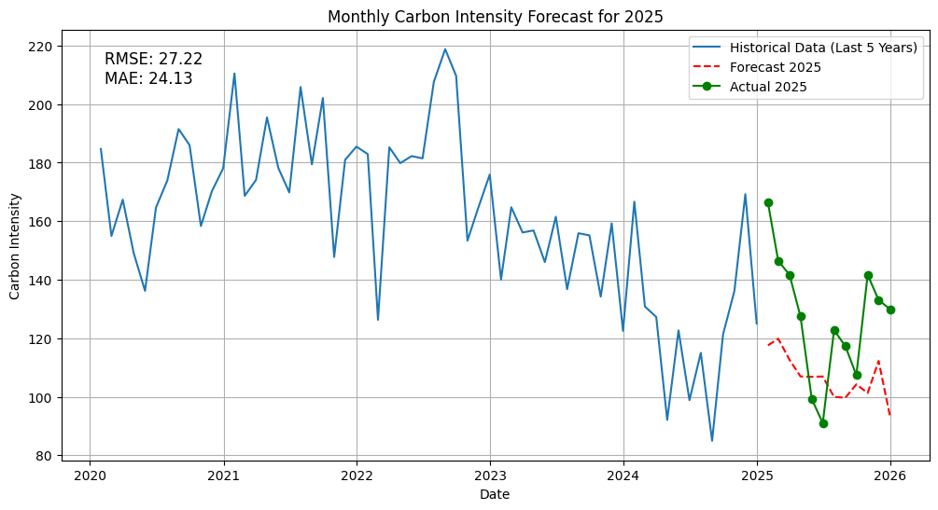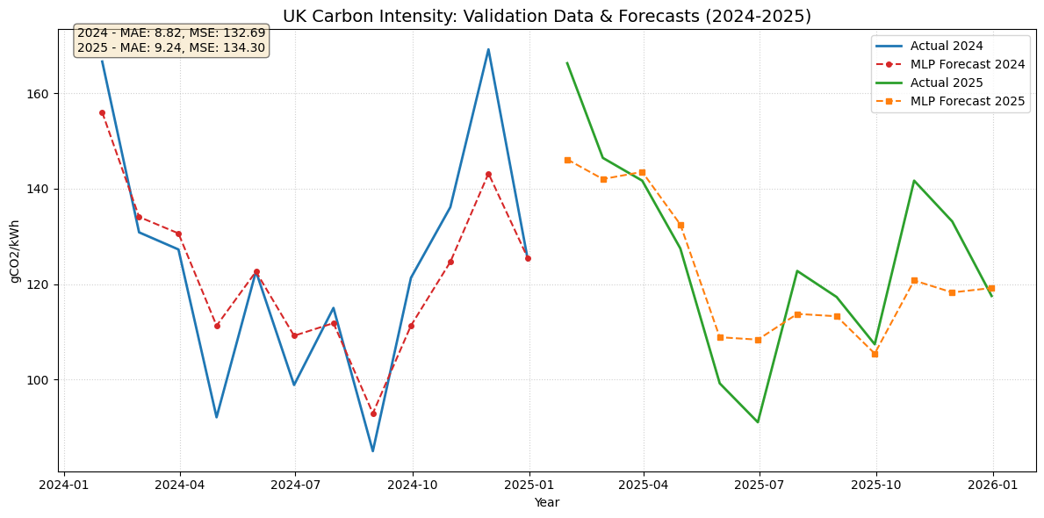
Figure 6 a) Monthly SARIMA forecast (subset of data) b) Monthly MLP forecast (subset of data)
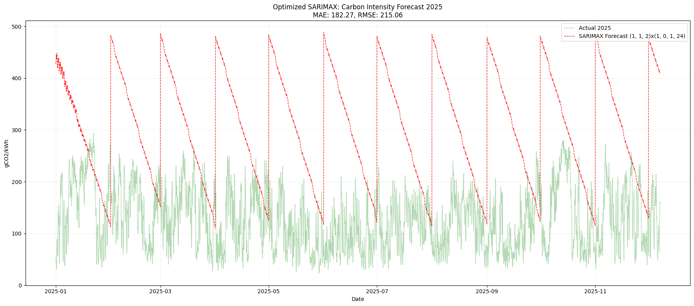
Figure 8 Hourly SARIMA forecast (subset of data: 20 days)
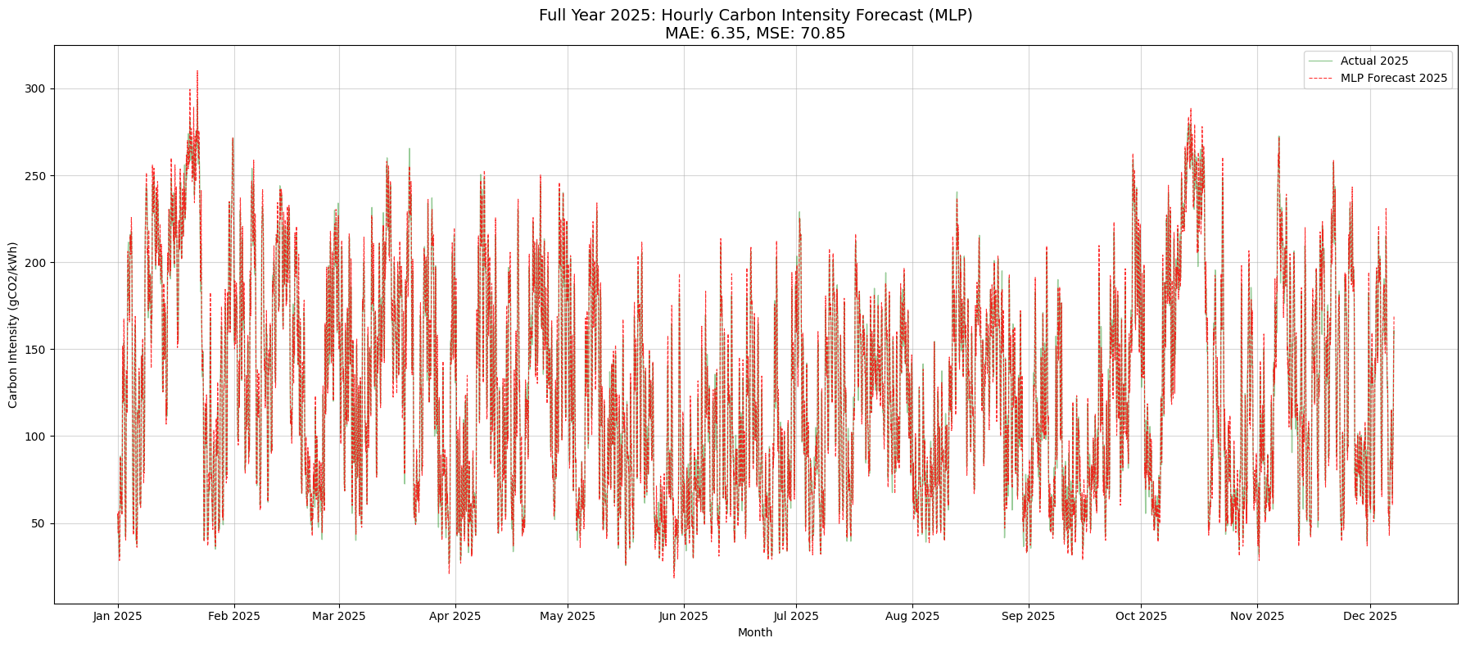
Figure 10 Hourly MLP forecast (subset of data)
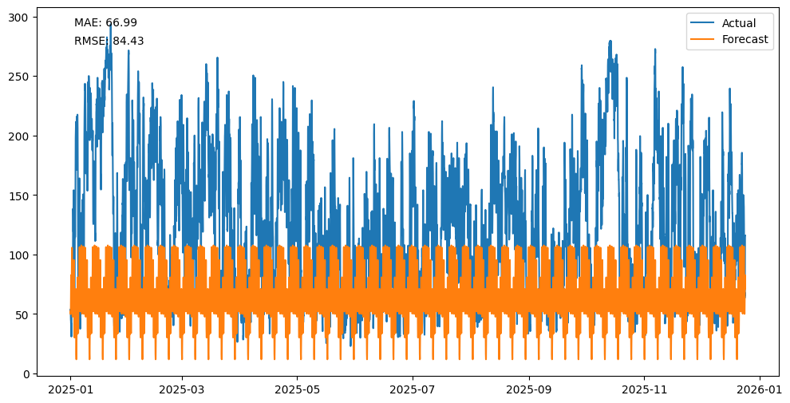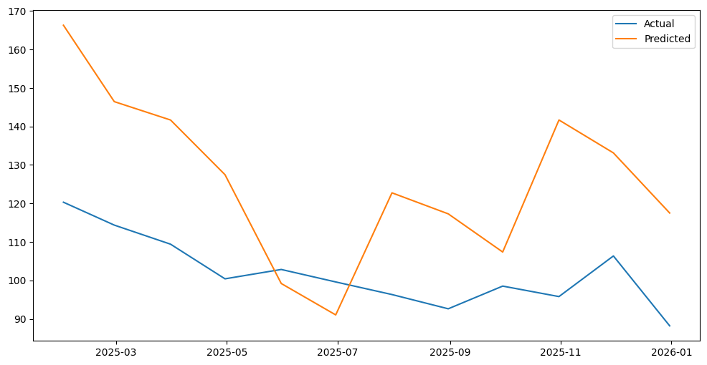
Figure 11 fully optimized forecasts a) Hourly ARIMA forecast b) Monthly ARIMA forecast
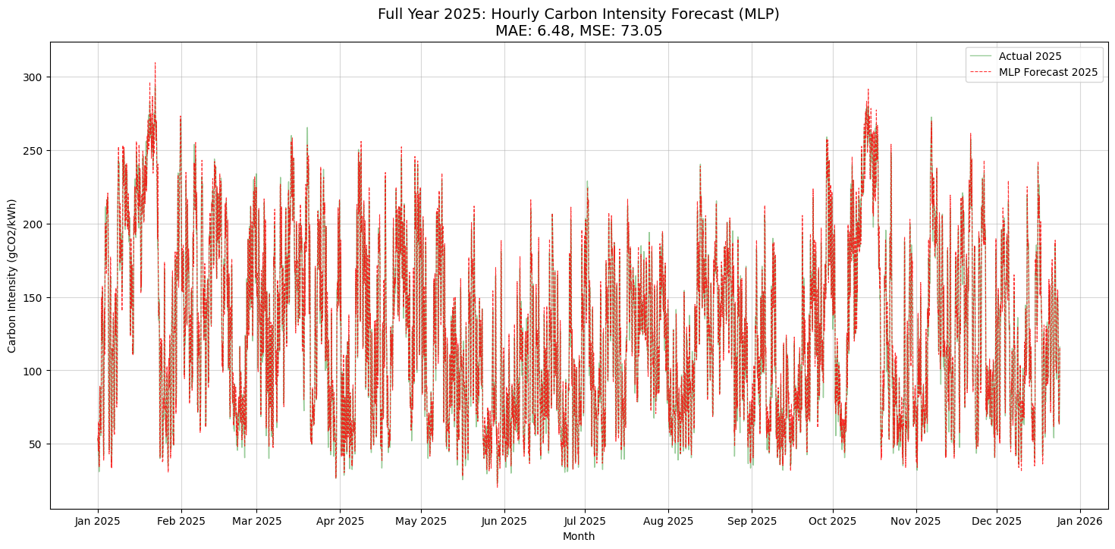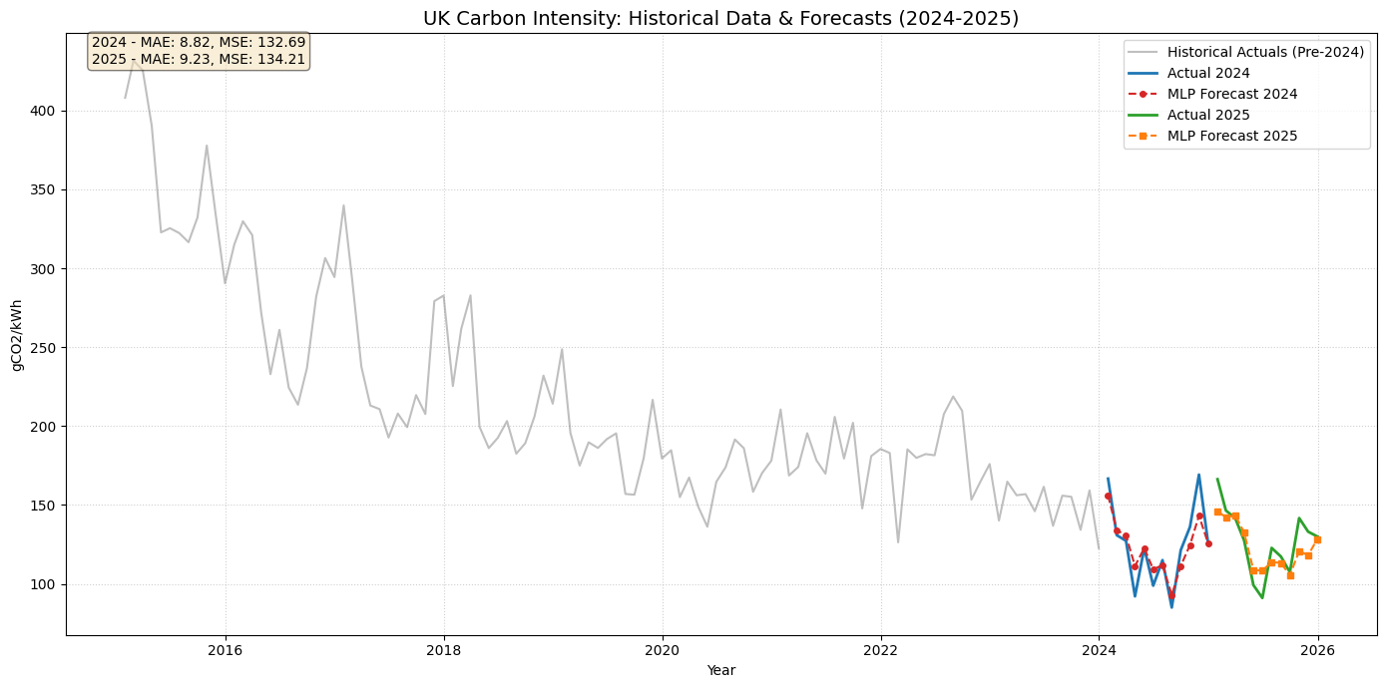
Figure 14 Hourly and Monthly MLP forecast (fully optimized)

Due to tractability issues on the machine
Looking at the visualisation, we can spot that these years have significantly different CI distribution.
Improvements from the previous optimisation methods are also included.

